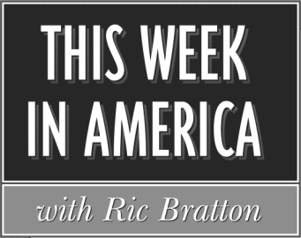

Affidavit for November 2024
Producer: Sean Bratton Host: Ric Bratton (www.thisweekinamerica.us)

Please sign and return by 12/25/2024
Blue Funk Broadcasting
c/o Production
121 Larchmont Terrace
Sebastian, FL 32958
Phone (260) 483-2116
Email production@bluefunkbroadcasting.com
Fax (772) 228-8130

Show 2024-45 Airdate and time:_______________
Show 2024-46 Airdate and time:_______________
Show 2024-47 Airdate and time:_______________
Show 2024-48 Airdate and time:_______________
Show 2024-49 Airdate and time:_______________
Advertiser Length

Tax Doctor :60
Smart Fares :60

Smart Fares :60
Whole Home Connect :60
Tax Doctor :60

(3rd spot break for 1 hr version)
Smart Fares :60
Tax Doctor :60

Shows aired on dates indicated, including commercials

Name_______________________________________

Title________________________________________

Email_______________________________________

Station______________________________________

City and State________________________________

